**Ideation Phase**

**Brainstorm & Idea Prioritization Template**

|  |  |
| --- | --- |
| Date | 27 June 2025 |
| Team ID | LTVIP2025TMID31213 |
| Project Name | EduTutor-AI- Personalized-  LearningwithGenerative- AI-and-LMSIntegration |
| Maximum Marks | 4 Marks |

**Brainstorm & Idea Prioritization Template:**

EduTutor AI aims to revolutionize the learning experience by harnessing the power of generative AI and seamless LMS integration. This innovative platform will provide personalized learning paths, intelligent tutoring, and adaptive assessments, ensuring that students receive tailored support and guidance. By leveraging cutting-edge technology, EduTutor AI will enhance student engagement, improve learning outcomes, and streamline educational processes for instructors. With its robust features and user-friendly interface, EduTutor AI is poised to transform the education landscape**.**

Reference: <https://www.mural.co/templates/brainstorm-and-idea-prioritization>

**Step-1: Team Gathering, Collaboration and Select the Problem Statement**

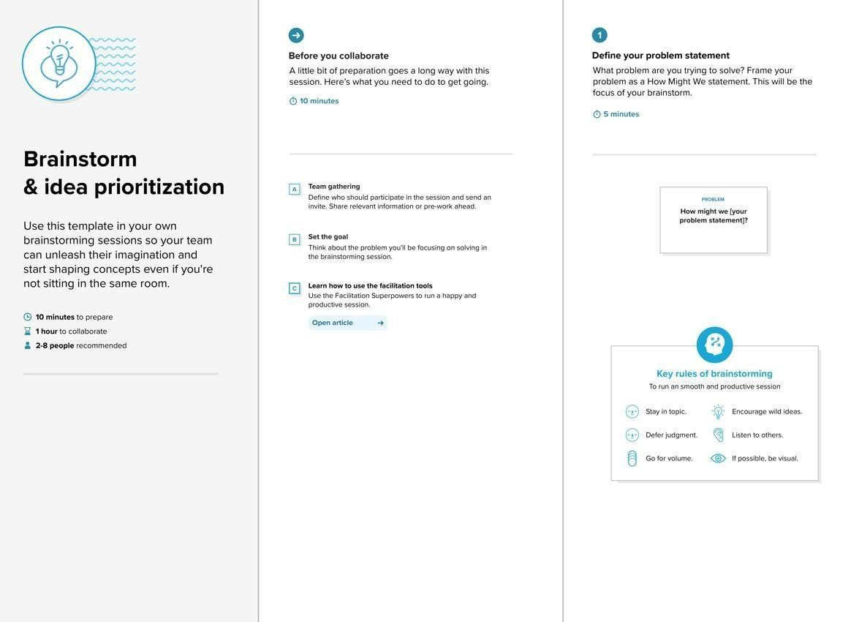

**Step-2: Brainstorm, Idea Listing and Grouping**

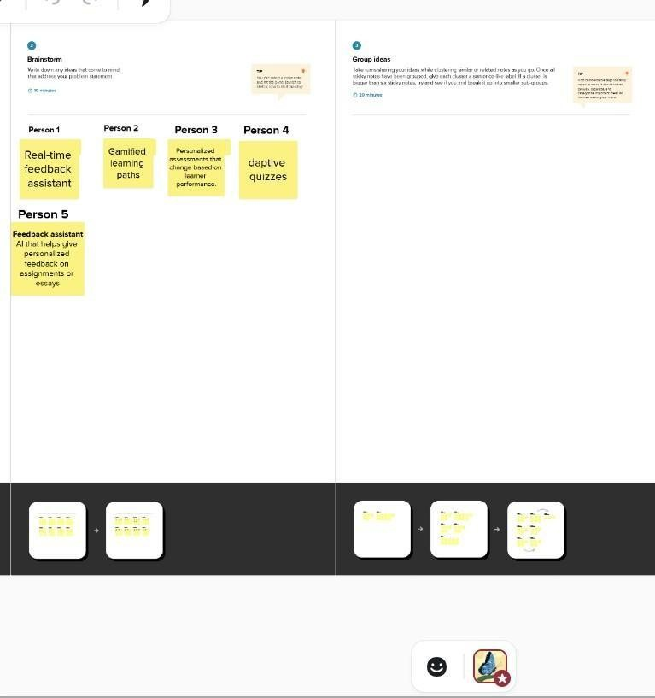

**Step-3: idea Prioritization**

